Function Components

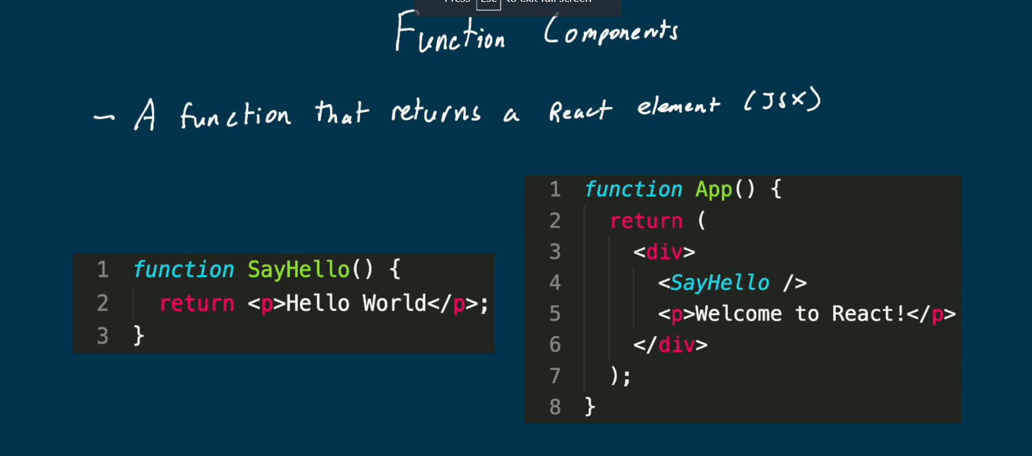

Inside the public file in a react app

Index.html 🡪 main file for our website

Inside the src file

* App.js is our first component
* index.js is the entry point of our application

whenever we want to use a css we import it

like import ‘./index.css’;

use ReactDOM.render(); to render react objects on the page

document.getElementById(‘root’) renders the element with id root from index.html to the page

* app.js

when including images, import the image then include in your tag

import logo from ‘./logo.png’;

<img src={logo} >

**JSX**

* Self closing tags and slash 🡪 <br />
* Return only return one element, that’s why we wrap everything in <div>
* If we don’t want the extra div we can use empty tags <> </> or use <React.Fragment> <React.Fragment/>

U can also return references like below to reference the const created

Conditional returning

**Attributes/Props**

Adding inline styles

Props are essentially are just attributes we add to tags